INDUSTRIAL VISIT
BUTWAL INDUSTRIAL AREA ASSOCIATION
Ramnagar,Butwal

REPORT

SUBMITTED TO: SUBMITTED BY:
Er. GANESH DATT JOSHI Roshan Kumar Hamal
National Academy of Science and Technology (NAST) Sandip Chand
Dhangadhi-4, Kailali, Nepal Kamala Mishra
Deepa Kumari Paneru
Janak Kadayat

It is really a matter of pleasure for us to get an opportunity to thank all the persons who contributed directly or indirectly for the successful completion of the field visit report “REPORT ON INDUSTRIAL VISIT OF BUTWAL INSDUSTRIAL AREA ASSOCIATION". First of all I am extremely thankful to our college National Academy of Science and Technology for providing us this opportunity and for all its cooperation and contribution. I also express my gratitude to our friends and teacher for helping us during this field visit. I am also grateful to all NAST faculties for their valuable guidance and suggestions for our study. I would like to thank Butwal Industrial Area Association team for extending their valuable time and cooperation for providing the valuable information of their company.

Introduction
The Butwal Industrial Area is a significant hub for industrial and economic activities in Nepal, located in the Rupandehi District of Province No. 5. Established in 2032 with investment from the Nepalese government, this industrial zone has developed its unique operational model and employs local manpower. Geographically, it is strategically situated with the Sukhora River to the east, Nepalese army barracks to the west, the West Highway and Shivnagar Community Forest to the north, and the Ramnagar Community Forest to the south. | 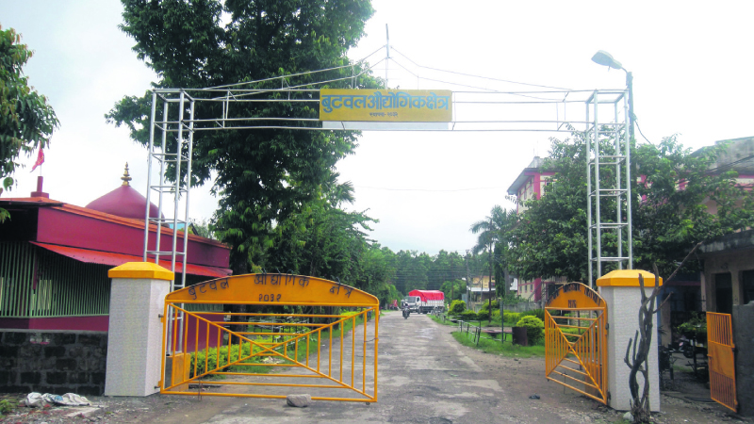
The industrial area is conveniently located just 3 km from the main market of Butwal, the temporary capital of Province No. 5. It is also near key trade routes, being 26 km from the Bhairahwa trade port, 28 km from India's Sunauli port, and 45 km from the sacred site of Lumbini. This makes it an accessible and attractive location for businesses and industries.
Butwal Industrial Area is known for its abundance of ferrous construction materials and a wide array of manufactured products. These include suspension bridges, hydropower construction materials, electrical components, iron poles, cables, wires, switchboards, cast iron products, plastic items, and various other goods such as chairs, dustbins, pipes, jerry cans, ropes, bags, steel and brass vessels, soaps, fabrics, and motorcycle helmets. The diversity of products highlights the versatility and industrial capability of the area.
The industrial zone has seen substantial private sector investment, amounting to 2.31 billion NPR, and provides direct employment to over 2,000 people. It significantly contributes to the local economy and government revenue, with recent figures indicating a contribution of approximately 35 million NPR in revenue. The Butwal Industrial Area stands as a vital economic engine for the region, fostering industrial growth, employment, and economic development.

Butwal Industrial Area
Establishment :- 2032 year Falgun 5th.
Area :- 434 crops
Developed land :- 434 plantations
Land leased :- 373.24 plantations
Butwal Industrial Area Industry Association :- 0.69 plant
Land occupied by utility services : - 60.07 plantations
Remaining land on lease :- None
Area of building leased : - 15,654.48 sqft
Area of warehouse building on lease : - 4965.72 sqft
Number of Employment (Total) :- 2042 people
Woman : - 487
Male : - 1534
Employed in the Area Management Office : - 21
Electrical capacity : - 4000 kVA
Water capacity :- 250 kg per day
Road extension :- 2.14 Km.
Investment
Of the government sector :- Rs. 1.79 crore
Of the private sector :- Rs. 2 billion 31 crores
Total industry no :- 72
Ongoing industry :- 64
Manufacturing industry :- 4
Vanda industry :- 4
Other association/institution :- 2(Sectoral Industries Association)
Production Capacity (Annual) :- Rs.4 billion 28 crores (estimated)
Contribution to Revenue (Annual) :- Rs.56 crore 20 lakhs

Services:
- Restitution of land and industrial buildings for 40 years.
• To restore the warehouse building for a maximum of 2 years.
• Regular power supply from a separate feeder.
• 24 hours water distribution.
• Providing health care, industrial resources and data

Visited Industries
- United Plastics Industries Pvt. Ltd
The United Plastic Factory, located in the Butwal Industrial Area of Rupandehi District, Province No. 5, Nepal, is a key manufacturer of plastic products. It produces a wide range of items such as plastic chairs, dustbins, pipes, pipe fittings, jerry cans, plastic bags, and ropes. | 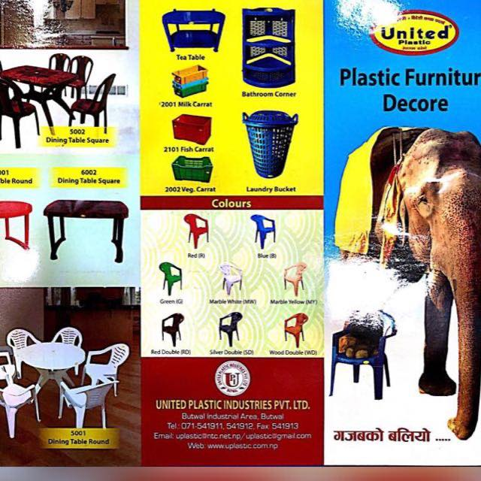
Mr.Tulsi Bahadur Gurung is the director of the United Plastic Industries Pvt. Ltd. According to the worker says plastic chairs are made in following ways: The manufacturing process of plastic chairs involves several steps, including the selection of materials, injection molding, assembly, and quality control.

- Material Selection:
The first step is to choose the appropriate type of plastic for the chair. Common plastics used for chairs include polypropylene (PP) & polyethylene (PE) due to their durability, strength, and recyclability. | 

- Injection Molding:
The selected plastic material is heated to a molten state and injected into a mold cavity. The mold is typically in two parts (core and cavity) and is shaped like the final chair design. The plastic is allowed to cool and solidify in the mold.

- Ejection  Once the plastic has solidified, the mold is opened, and the newly formed chair component is ejected. This process may involve mechanical ejection or the use of air pressure to release the molded part. | 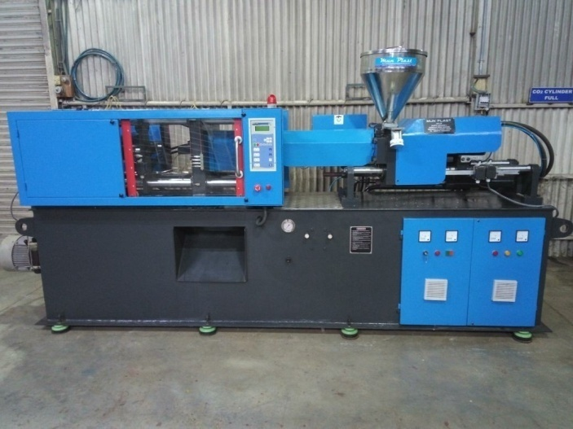

- Finishing:
The assembled chairs may undergo finishing processes, such as trimming excess plastic, smoothing edges, or adding texture to the surfaces.Finishing enhances the aesthetic appeal and comfort of the chairs.

- Quality Control:  The manufactured plastic chairs go through rigorous quality control checks.This may include inspections for structural integrity, dimensional accuracy,and visual defects.Chairs that meet the quality standards proceed to the next steps, while any defective units are either reworked or discarded. | 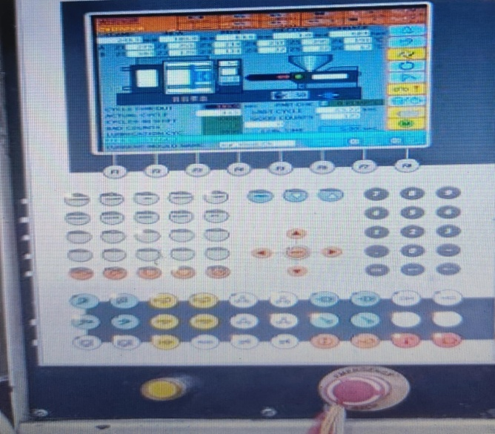
- Packaging:
Once the chairs have passed quality control, they are packaged for shipping. Packaging materials are chosen to protect the chairs during transportation.

2. Metal Cast Pvt Ltd.  Metals cast are a foundry serving Nepalese Industries for their requirement of casting and fabrication of various metals. Metals cast produces components of Ferrous Alloys, Copper alloys and Aluminum through green sand molding processes. Metals casts was established in 2049 B.S. It started as a jobbing foundry with focus on requirements of industries in and around Butwal. Metals cast has the advantage of successfully producing thousand | 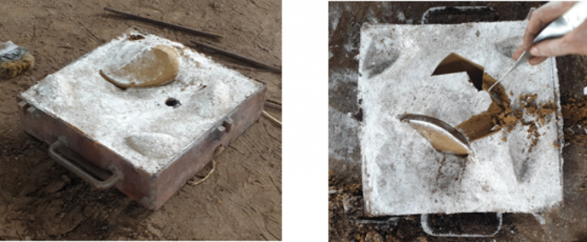
type of products to customer satisfaction which makes it versatile in producing a wide range of customer requirement, however complex it may be. It has the capacity of producing up to 25,000 Molten Steel per day and up to 2500 Kg single casting of ferrous alloys and copper alloys.
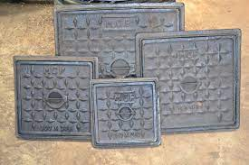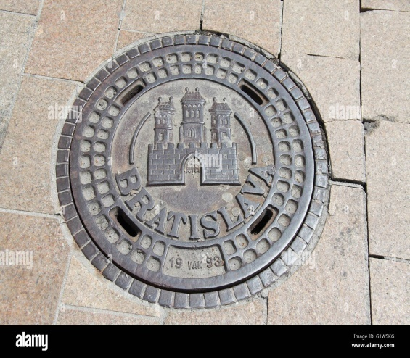

Ground Report of Visited Industry
On July 1st we left for Butwal early in the morning at 8:00 AM after consulting with Butwal Industrial District Management Office. We reached Butwal by 8:00 PM after a long 12 hour bus trip. We reserved a hotel and stayed that night in the hotel “Morning Dew”.
Early in the morning we visited the religious place Siddha Baba temple and worshiped there. | 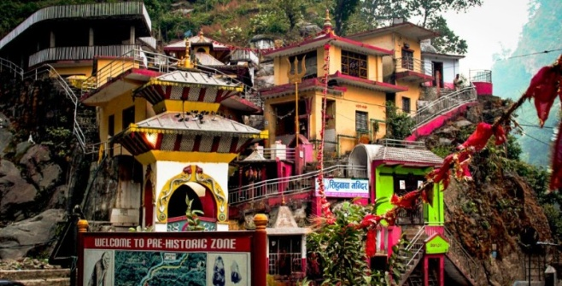
After worshiping at Siddha Baba Temple we went back to hotel and had our lunch in the hotel.After having lunch we headed toward our main destination “Butwal Industrial Area” around 11:00 AM. After reaching there shortly we first visited the “United Plastic factory”.  In United Plastic factory we saw how plastic equipment like chairs, stools, tables, mugs, etc were manufactured. | 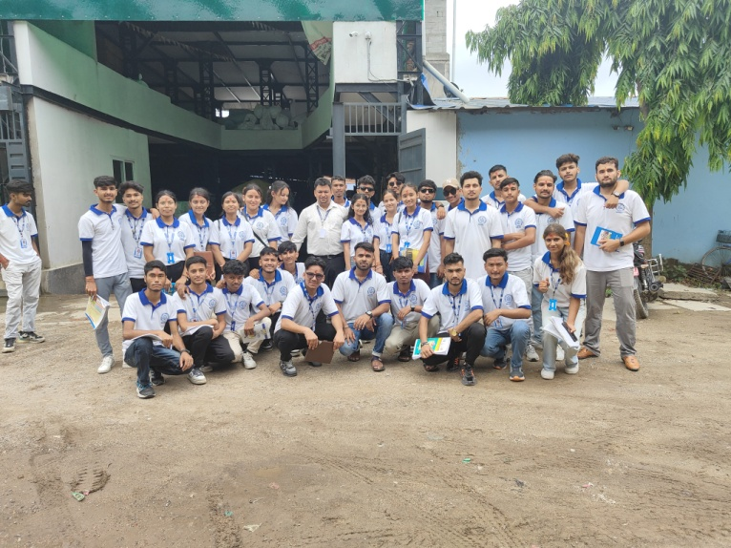

After visiting United Plastic Factory we went to Metal casting Factory were designs and logos were casted in the big metal stuffs. We saw metal road blocks, manhole covers, etc. The black sand-like substance was used in metal casting which is called foundry sand or casting sand. It is often made from high-quality silica sand, which can be mixed with various binders to hold the mold together | 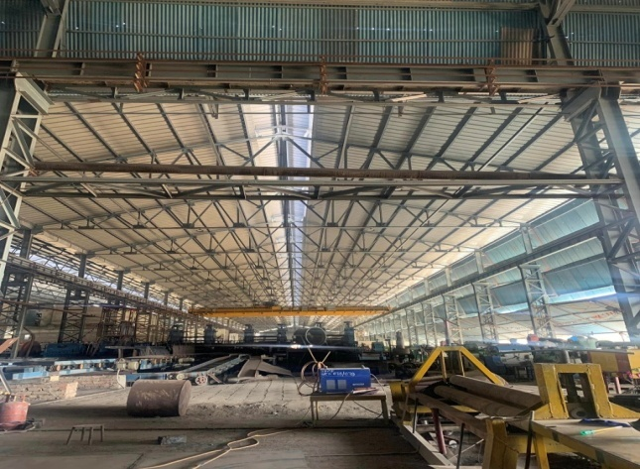
After visiting them we went to visit “BUTWAL ELECTRIC AND TRANSFORMER WORKS” where transformers were manufactured and assembled. We saw the dissembled transformers and got to know about its working and manufacturing mechanism. | 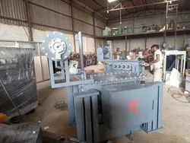

After visiting Butwal we moved forward to visit lumbini(Birth place Of Lord Gautam Buddha). After a trip of an hour we reached lumbini and visited the Maya Devi temple and enjoyed the night view of Maya devi temple and Lumbini area. After that we went back to hotel where we were staying and had our dinner at “365 resturant”. After dinner we cut the cake and celebrated the visit and went back to bed. | 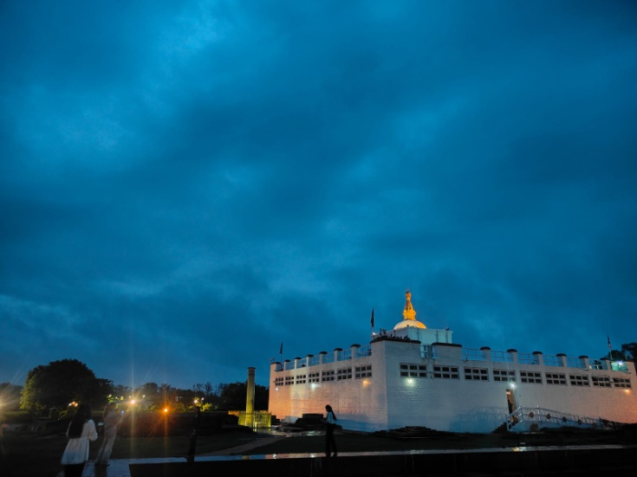

The next day we experienced a heavy rainfall and unable to execute our plan. But after we had our lunch at 11:00 AM the rain stopped and we went to visit different Monasteries and Gumbas of different countries. After roaming around lumbini we went to visit world peace stupa and after half an hour we returned back to Dhangadhi and arrived here in the morning of 4th july. | 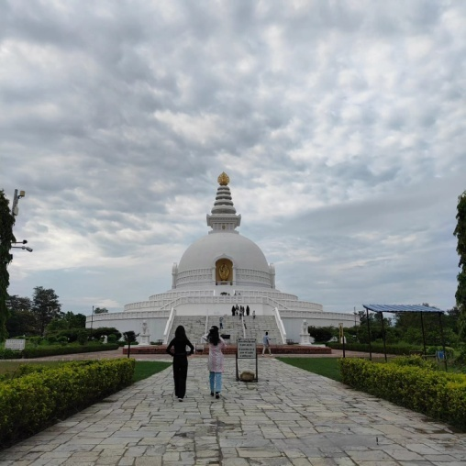
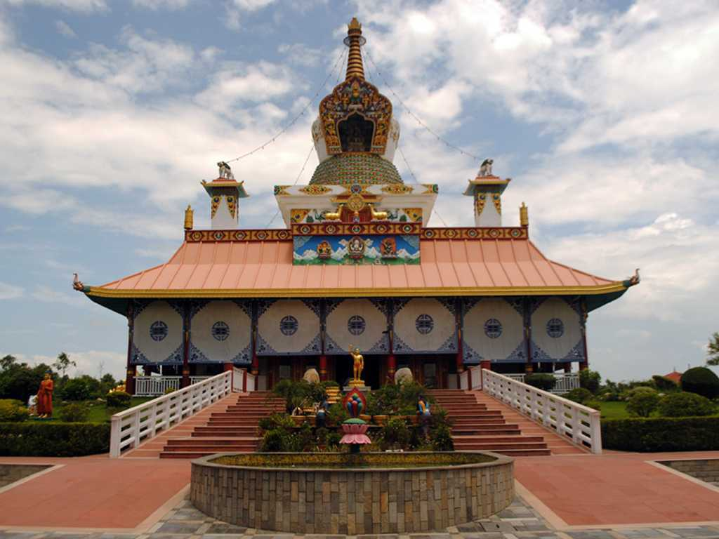
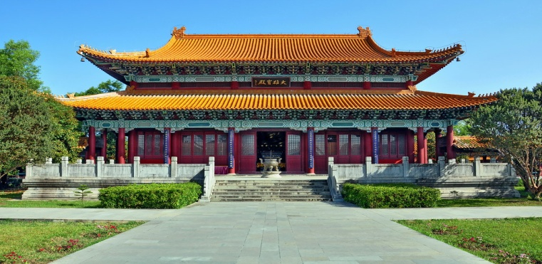

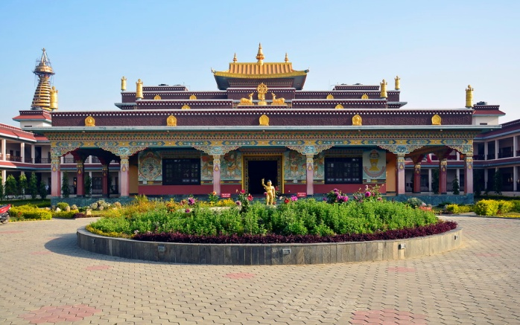
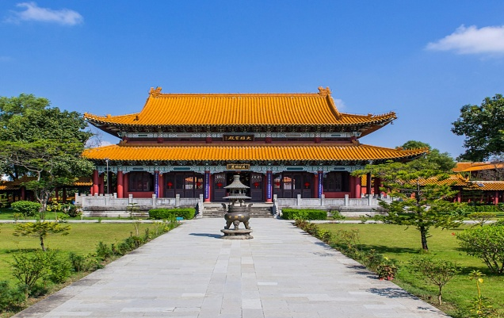
CONCLUSION
This visit offered us a valuable learning experience into the industrial landscape of Butwal and underscored the importance of industries in fostering economic growth and development. We gained a deeper understanding of industrial operations and practical insights into the production process. The visit also provided an opportunity to observe several unique features and innovations in the production process, enhancing our comprehension of the industry.

